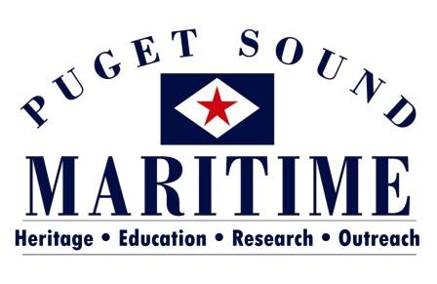

Job Title: Database Manager
Duration: P/T Term (not to exceed 2 years)
Wage: $15/hour
Location: MOHAI Resource Center
Schedule: Flexible hours M-F, 9:00am-5:00pm
Job Description:
Puget Sound Maritime (PSM) is dedicated to preserving and promoting the maritime heritage of Puget Sound and the Pacific Northwest. To that end, we have a full collection of artifacts, archives, photographs, ships plans, and books. Located in the Museum of History and Industry’s Resource Center, PSM our collection is available to researchers and exhibit loans. In the interest of expanding the audience for and public access to our collections, we plan to make our database available online.
Under the supervision of the Director, the Database Manager will be responsible for preparing and launching our online database. Working with Puget Sound Maritime staff and volunteers, the Database Manager will prepare existing collections records for public access. This will involve standardizing nomenclature, completing missing data, adding photographs and photo scans, adding new catalog records, and resolving miscellaneous database inconsistencies.
In the second phase of this project, the Database Manager will work with PSM staff and volunteers to create online exhibits and education activities using the online collections database. This portion of the job will include researching and developing online exhibit content, researching and developing online education activities, and publishing at least one online exhibit.
We use PastPerfect database and will be purchasing PastPerfect Online and Virtual Exhibit for the completion of this project.
Job Requirements:
For this position, candidates must be able to use PastPerfect database systems, be proficient in research, climb ladders, and lift a minimum of 30lbs. Candidates should have experience in museum work and demonstrate current understanding of library and museum best practice standards regarding artifact and archive handling and data management. Preference will be given to candidates with a minimum of a B.A. in Museology, Library Sciences, History, or related fields (or equivalent experience), as well as to those who have experience with PastPerfect.
To apply, please submit resume and cover letter to Alicia Barnes at admin@pugetmaritime.org.

