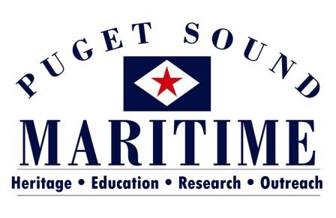

PO BOX 81142
SEATTLE, WA 98108
206.812.5464
collections@pugetmaritime.org

Library and Archives Internship Opportunities
2017

The Puget Sound Maritime Historical Society is located within MOHAI’s Resource Center in the Georgetown neighborhood of Seattle, 5933 6th Avenue South. We have a variety of opportunities available. You’ll get the experience of working with a very small organization that is partnered with the AAM Accredited Museum of History and Industry. You would be working with the Director, Alicia Barnes (MA in Museology, University of Washington) and a variety of volunteers. Find out more about our organization at www.pugetmaritime.org.

Project: Book Collection Accessioning
Timeline: Any time Fall 2016 – Summer 2017 Days: Flexible, Monday – Friday between 10 a.m. and 4 p.m.
The project focuses on our library’s collection of books, which are tracked using the Dewey Decimal System. We aim to prepare the library collection for our PastPerfect Online database. For this project, an intern will: 1) Arrange books according to their Dewey numbering system; 2) Enter location, brief description/key words, and identifying photograph(s) into PastPerfect database; and 3) Identify books eligible for deaccessioning.

Project: Archives Processing
Timeline: Any time Fall 2016 – Summer 2017 Days: Flexible, Monday – Friday between 10 a.m. and 4 p.m.
This project focuses on our archival collection, which has never been fully catalogued. Currently accessible only by use of a rough index, our archival materials need to be identified, catalogued and entered into our PastPerfect database. Materials in our archives range from old newspapers to photo albums; log books to periodicals; photographs to correspondences. This project will not only foster museum skills, but also spark the interest of history buffs and researchers. This intern will gain experience in 1) archival handling and preservation, 2) cataloging methods, and 3) working in PastPerfect database. There is also the potential for digitization experience in the scope of this project.

Project: Scrapbook Preservation
Timeline: Anytime Fall 2016 – Summer 2017 Days: Flexible, Monday - Friday, between 10 a.m. and 4 p.m.
This continues a project focused on archivally re-housing a scrapbook collection. This collection of six scrapbooks includes photos and newspaper articles. This position gives an intern: 1) skills in entering data into PastPerfect database; 2) experience in scanning images and newspaper; 3) practice in preserving scrapbook materials.

For additional information about any of these opportunities or to discuss an internship you would like to explore please contact Alicia Barnes:
admin@pugetmaritime.org or 206.812.5464

