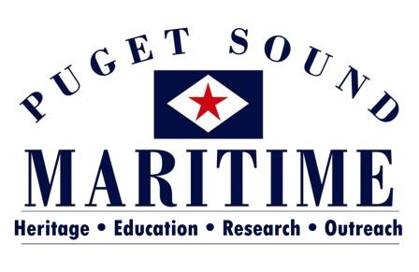
PO BOX 81142
SEATTLE, WA 98108
206.812.5464
admin@pugetmaritime.org

EDUCATION INTERNSHIP OPPORTUNITIES
2017

The Puget Sound Maritime Historical Society is located within MOHAI’s Resource Center in Georgetown, 5933 6th Avenue South. We have a variety of opportunities available. You’ll get the experience of working with a very small organization that is partnered with the AAM Accredited Museum of History and Industry (MOHAI). You would be working with the Director, Alicia Barnes (MA in Museology, University of Washington) and a variety of volunteers.

Project: YMTA Teen Docent Program
Timeline: Fall 2016 to Summer 2017
Days: Any day(s) Monday - Friday, between 10 am and 5 pm; could also have work-from-home components.
Description: This internship focuses on our newest branch, the Youth Maritime Training Association. YMTA aims to inform youth about the maritime job industry and provide them with the resources they need to enter the field. To tie this program to our heritage function, the YMTA intern will: 1) Continue to build and develop our Teen Docent program, by creating a standardized training for volunteers; 2) Recruit the first round of teens; 3) Implement the training and help teens complete their volunteering commitment.

Project: First Thursday PSM Education Program in the McCurdy Family Maritime Gallery at MOHAI
Timeline: Anytime Fall 2016 to Summer 2017
Days: First Thursdays at MOHAI, plus other times as needed.
Description: Great for anyone who is creative and enjoys interacting with children and families, this internship aims to create several new Free First Thursday activities that are both educational and fun for MOHAI visitors.
This internship involves: 1) Developing inexpensive maritime-themed, hands-on, take home activities for children; 2) Coordination of volunteers to help with the activities on the first Thursday of each month; 3) Serving as the lead person with the hands-on activity for children on First Thursdays.

Project: Online Activities/Resources
Timeline: Any time Fall 2016 to Summer 2017
Days: Any day(s) Monday – Friday, 10 am to 5 pm
Description: As we prepare to launch our new website, we are looking to expand our online content, including educational activities. This intern will 1) Research downloadable education content; 2) Establish learning goals for downloadable content; and 3) Create maritime-themed education activities for different age groups.

For additional information about any of these opportunities or to discuss an internship you would like to explore please contact Alicia Barnes:
admin@pugetmaritime.org or 206.812.5464

