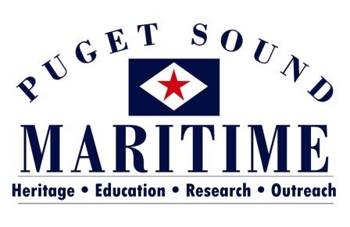

PO BOX 81142
SEATTLE, WA 98108
206.812.5464
collections@pugetmaritime.org

COLLECTIONS MANAGEMENT INTERNSHIP OPPORTUNITIES
2017

The Puget Sound Maritime Historical Society is located within MOHAI’s Resource Center in the Georgetown neighborhood of Seattle, 5933 6th Avenue South. We have a variety of opportunities available. You’ll get the experience of working with a very small organization that is partnered with the AAM Accredited Museum of History and Industry. You would be working with the Director, Alicia Barnes (MA in Museology, University of Washington) and a variety of volunteers. Find out more about our organization at www.pugetmaritime.org.

Project: Rotating Exhibitions
Timeline: Anytime Fall 2016 to Spring 2017 Days: Flexible. Monday – Friday between 10 am and 5 pm
This internship will benefit the Society as it strives to bring its collection to the public. This internship will involve conceptual work as well as some artifact handling. The intern will create content for our exhibit in MOHAI’s fourth floor gallery, the McCurdy Family Maritime Gallery. Currently there are six exhibit cases that are semi-permanent, having originally been considered ‘rotating’ on a yearly basis. We are looking to rotate out at least one set of cases at this time. This position gives an intern: 1) great skills in planning ahead and creating timelines; 2) experience conceptualizing exhibits using existing collections and loaned objects; 3) practice in budgeting and pricing exhibition materials, installations, and de-installations; 4) experience consulting with MOHAI exhibit staff.

Project: Object Photography and Accessioning (Objects & Archival)
Timeline: Anytime Fall 2016 to Summer 2017 Days: Flexible. Monday – Friday, between 10 am and 5 pm
This project is great for anyone who loves to get ‘hands-on’ with objects. The internship consists of completing the photography of our collection and adding the images added to their PastPerfect database file. Condition reporting may be included in this project. In addition, we have some donations reaching back to 2012 that need to be processed. This project helps us prepare to have our collections online through PastPerfect Online and gives an intern: 1) skills in object photography; 2) PastPerfect database entry; 3) practice in the process of accessioning items into a collection.

For additional information about any of these opportunities or to discuss an internship you would like to explore please contact Alicia Barnes:
admin@pugetmaritime.org or 206.812.5464

