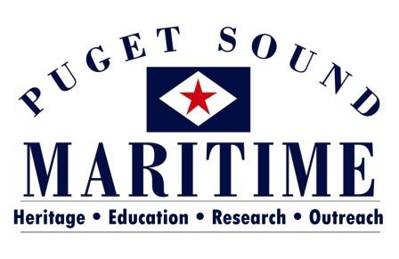

PO BOX 81142
SEATTLE, WA 98108
206.812.5464
collections@pugetmaritime.org

COLLECTIONS MANAGEMENT INTERNSHIP OPPORTUNITIES
Fall 2017 – Summer 2018

The Puget Sound Maritime Historical Society is located within MOHAI’s Resource Center in the Georgetown neighborhood of Seattle, 5933 6th Avenue South. We have a variety of opportunities available. You’ll get the experience of working with a very small organization that is partnered with the AAM Accredited Museum of History and Industry. You would be working with the Director, Alicia Barnes (MA in Museology, University of Washington) and a variety of volunteers. Find out more about our organization at www.pugetmaritime.org.

Project: Online Exhibitions
Timeline: Anytime Fall 2017 to Spring 2018 Days: Flexible. Monday – Friday between 10 am and 5 pm
This internship will benefit the Society as it strives to bring its collection to the public. The project will involve conceptual work as well as some artifact handling. The intern will create content for online exhibits using objects, photos and archives, working within our exhibits software. This position gives an intern: 1) experience in developing an exhibit story; 2) practice researching a specific topic using collections and digitized records; 3) experience digitizing archival documents and photos as needed; and 4) experience working with online exhibit software.

Project: Condition reporting and Accessioning (Objects & Archival)
Timeline: Anytime Fall 2017 to Summer 2018 Days: Flexible. Monday – Friday, between 10 am and 5 pm
This project is great for anyone who wants to gain experience with basic collections management tasks. The project consists of condition reporting objects in the collection, particularly those currently on exhibit and cataloging incoming collections. Some object photography and archival digitizing will be required. This project helps us maintain collections preservation standards and gives an intern: 1) experience cataloging objects, archives and photograph collections in PastPerfect; 2) experience handling and digitizing photos and documents; 3) experience conducting condition reports.

Project: Rolled Textiles
Timeline: Anytime Fall 2017 to Summer 2018 Days: Flexible, Monday – Friday between 10 am and 5 pm
This project is great for someone who wants to become familiar with textile handling! The project focuses on rehousing our ship flags collection (approximately 150) from current folded storage to rolled storage. Flags will also need to be photographed and have locations updated in the database. The project helps with our conservation efforts and gives an intern 1) experience handling oversized textiles; 2) an understanding of the materials needed for textile preservation; 3) experience photographing oversized objects; and 4) practice working in the PastPerfect database.

For additional information about any of these opportunities or to discuss an internship you would like to explore please contact Alicia Barnes:
admin@pugetmaritime.org or 206.812.5464

