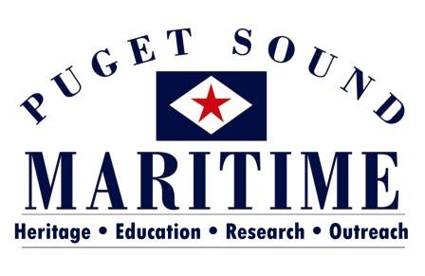

PO BOX 81142
SEATTLE, WA 98108
206.812.5464
collections@pugetmaritime.org

Library and Archives Internship Opportunities
Fall 2017-Summer 2018

The Puget Sound Maritime Historical Society is located within MOHAI’s Resource Center in the Georgetown neighborhood of Seattle, 5933 6th Avenue South. We have a variety of opportunities available. You’ll get the experience of working with a very small organization that is partnered with the AAM Accredited Museum of History and Industry. You would be working with the Director, Alicia Barnes (MA in Museology, University of Washington) and a variety of volunteers. Find out more about our organization at www.pugetmaritime.org.

Project: Book Deaccessioning
Timeline: Any time Fall 2017 – Summer 2018 Days: Flexible, Monday – Friday between 10 am and 5 pm
The project focuses on our library’s collection of books, which we aim to make accessible to the public through our new PastPerfect Online database. For this project, an intern will: 1) Update PastPerfect database records in our library catalog; 2) Identify books eligible for deaccessioning; 3) and assist with the transfer of deaccessioned books to other institutions.

Project: Photograph Scanning
Timeline: Any time Fall 2017 – Summer 2018 Days: Flexible, Monday – Friday between 10 am and 5 pm
This project focuses on our Joe Williamson photograph collection, which consists of over 10,000 photos. Currently accessible only by our research volunteers, we’d like to have the photographs scanned and added to our PastPerfect Online database to increase public access. This project will not only foster museum skills, but also spark the interest of history buffs and researchers. This intern will gain experience in 1) photo handling and digitizing; 2) working with photoshop software; and 3) connecting media to database records using PastPerfect.

Project: Scrapbook Preservation
Timeline: Anytime Fall 2017 – Summer 2018 Days: Flexible, Monday - Friday, between 10 am and 5 pm
This continues a project focused on archivally re-housing a scrapbook collection. This collection of six scrapbooks includes photos and newspaper articles. This project gives an intern: 1) skills in entering data into PastPerfect database; 2) experience in scanning images and newspaper; 3) understanding best practices for preserving scrapbook materials.

For additional information about any of these opportunities or to discuss an internship you would like to explore please contact Alicia Barnes:
admin@pugetmaritime.org or 206.812.5464

